The USA Memory Championship consists of a variety of challenges, where those competing are asked to memorize names and faces, numbers, cards, and even poetry. Today we are going to do a version of this competition, by spending some time memorizing some letters, and some numbers, and seeing how many of each you can recall.

**1.** Given a string of letters, and a string of numbers, do you think it would be more difficult to memorize letters or numbers? Explain your reasoning.

**2.** Your instructor is going to project a series of numbers, and you will be given one minute to memorize as many of them, in order, as you can. You will then be given 30 seconds to write as many of those numbers, in order, below.

Correct: ____________

**3.** Your instructor is going to project a series of letters, and you will be given one minute to memorize as many of them, in order, as you can. You will then be given 30 seconds to write as many of those letters, in order, below.

Correct: ____________

**Fun Fact:** As of 2019, the current record holder for maximum memorization of numbers in five minutes was Alex Mullen in 2016 with **483** digits!

**4.** Find the mean and standard deviation for each of the two class data sets. Number of values in the population:______

|  |  |  |
| --- | --- | --- |
| Numbers |  |  |
| Letters |  |  |

**5.** Draw the histogram that represents the data for the number of letters memorized. It will help to sort the data in numerical order in your calculator first.

Population Distribution

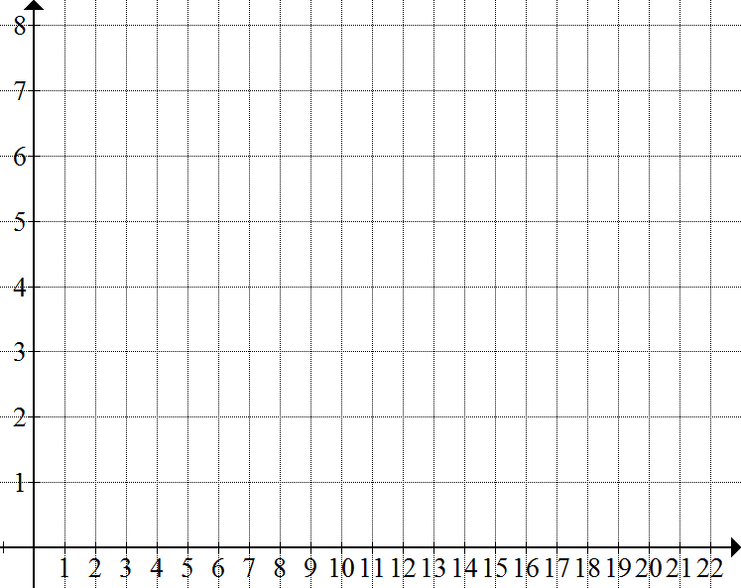

Frequency

Number of letters memorized

**6**. Now your instructor is going to create the sampling distributions of the sample means for your data. As you look at the sampling distributions, make note of the mean and standard deviation of each.

|  |  |  |  |
| --- | --- | --- | --- |
|  | Mean | Standard Deviation | Shape of the Sampling Distribution |
|  |  |  |  |
|  |  |  |  |
|  |  |  |  |

**8.** Use technology or tables to answer the following questions (using the Central Limit Theorem).

**a.** Find the probability that the mean amount of letters memorized by a randomly selected group of five people in the class was more than twelve.

**b.** Find the probability that the mean amount of letters memorized by a randomly selected group of ten people in the class was more than twelve.